**Extracting Data** : We need to extract data from the data source which may be in many formats like excel, text, csv etc., here the data set is in csv file, so choose Text/CSV option and then select the required file to load

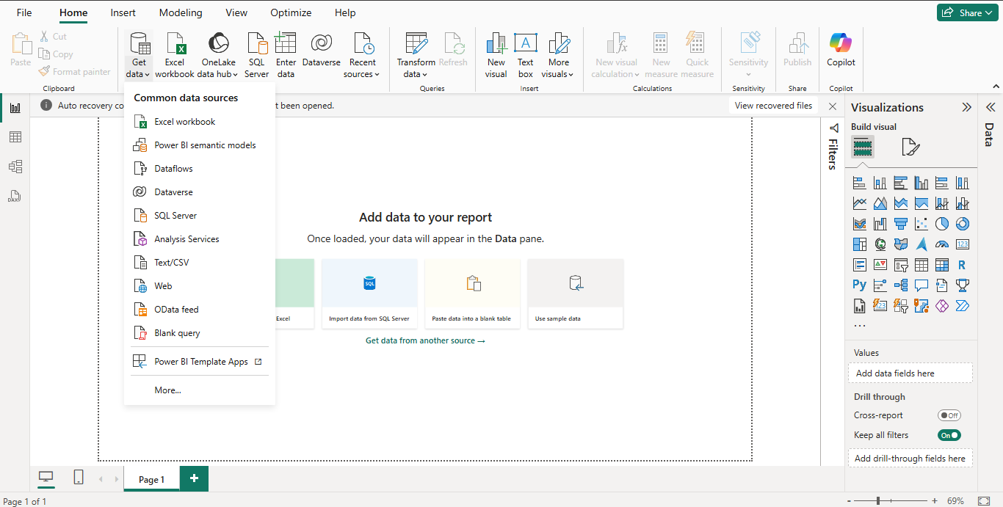

**Loading Data:** After extracting data we get this window it has two options

* Load : Need to select when the data is cleaned
* Transform Data : Need to select when we want to process the data

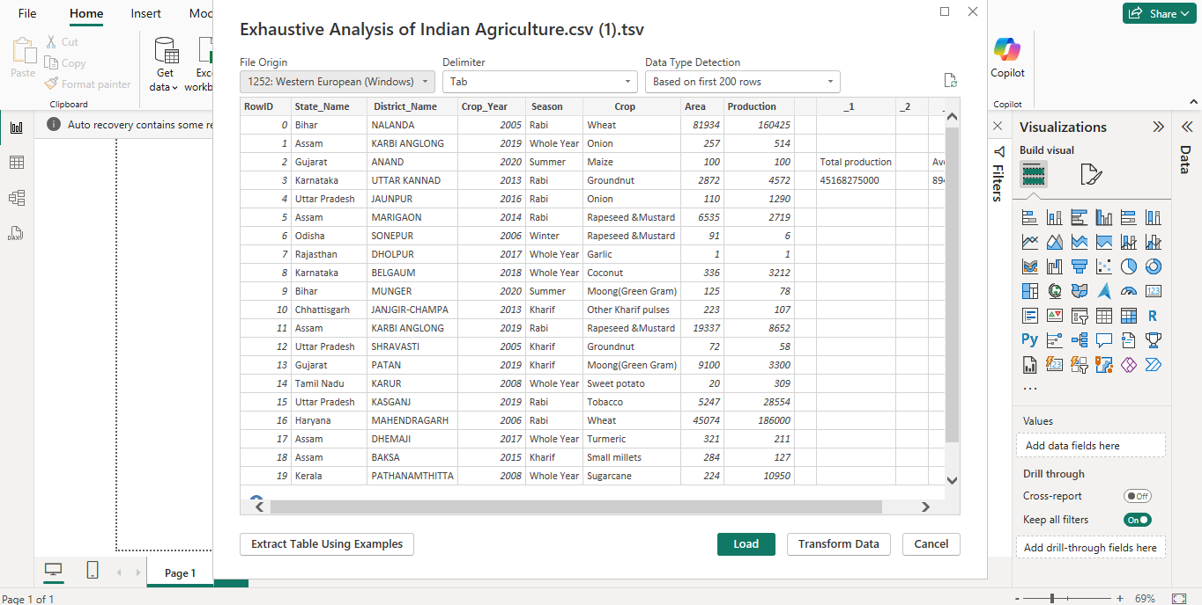

**Power Query Editor** : After selecting Load option we get a new window Power Query Editor where we can perform operations on data

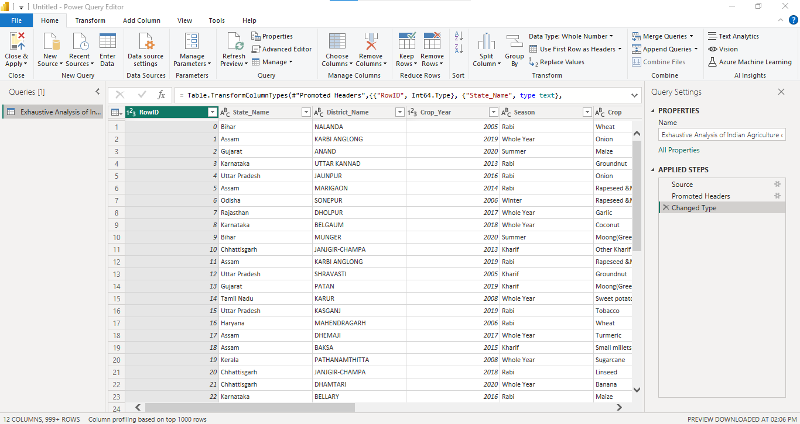

**Transform Data** : Need to select Transform data tab and select transform data option then we get there types of views

* Report View : It is used for visualization of data
* Table View: It is to see data in table format
* Model View: When we want to merge data and to create relationship among data

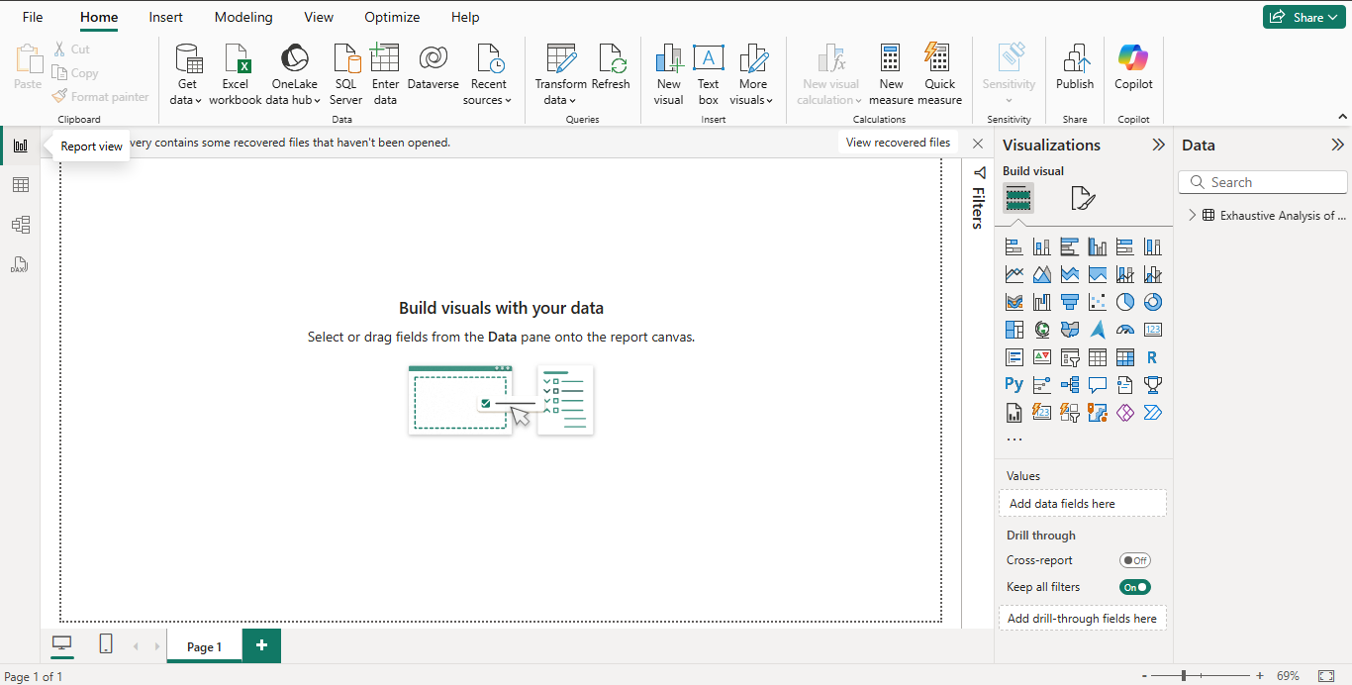

**Remove Columns:** Inorder to remove unnecessary columns we need to select the particular column and select remove option. Here all the unnessary columns are removed from the table

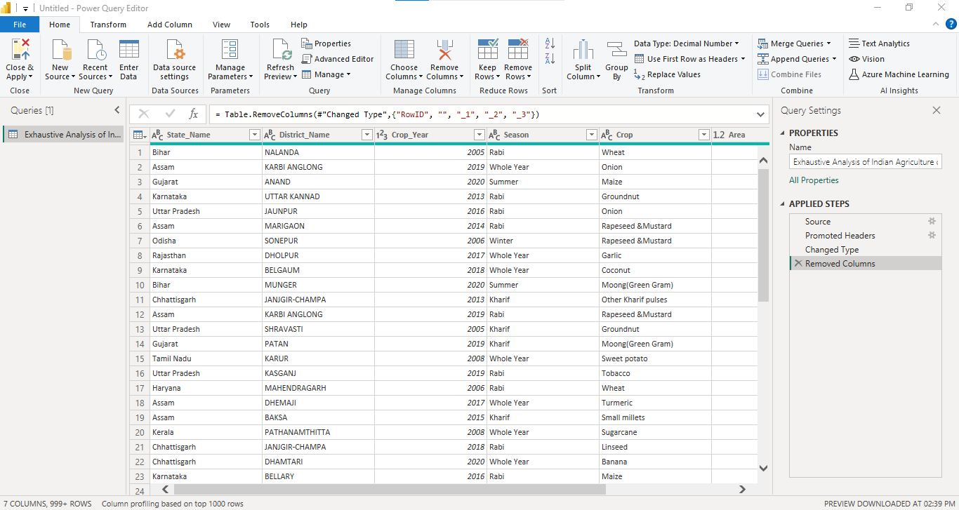

**View tab :** In order to check whether there are any null values present in the data we need to select view tab and then select column quality option, here we can see any null values

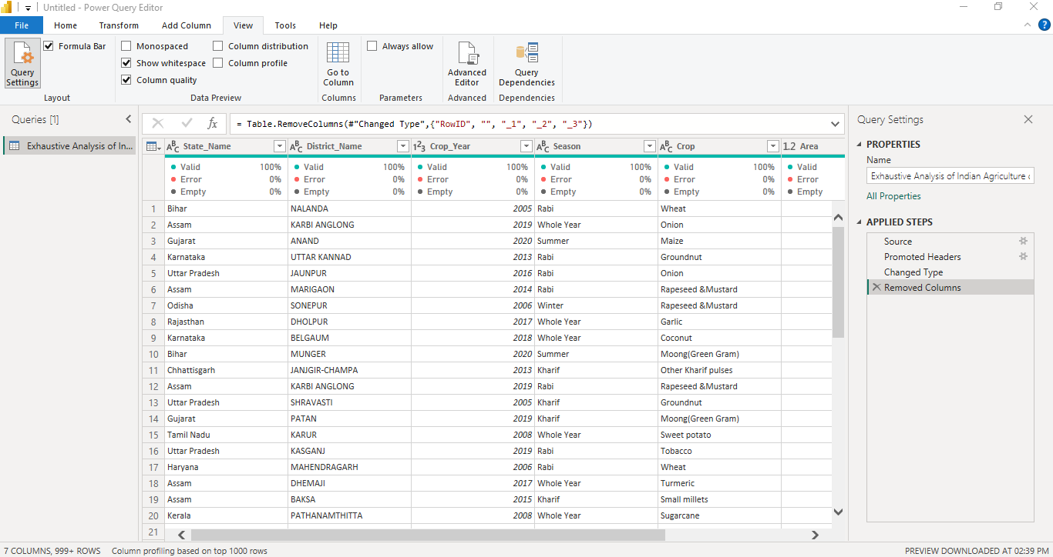

**Save changes:** After performing all operations we need to save the file by selecting home tab and then select close and apply option. The below table is the final data file in table view

